Do the Final exam, submitting both PDF answers and code you have written:

- Get the latest PROG1400 repo. Minor changes were made to allow direct use for this final.
- Add a PROG1400/Final directory for answers in your Repo [project Final, java packages Q1, Q2, … etc…]
- Questions answered as text, are placed in this file, made PDF, and saved in the final project directory with your final code.
- Also upload your PDF to D2L, showing you finished the Final.

You have access to all of your git repo, and mine for any questions. You also have access to the internet, but be mindful of the poor solutions you can get in the internet.

MainSort Main line snippet
public class MainSort {

public static void main (String[] args) {
Bubble_Sort b1 = new Bubble_Sort("abcdefga");
b1.sort_1();
b1.printAll();

Bubble_Sort b2 = new Bubble_Sort("abcdefga");
b2.sort_2();
b2.printAll();
}
}

- Find The BubbleSort Java Code in the PROG1400 repo, and run the MainSort Main line
[Located at … “PROG1400\Eclipse_WS\Module-01-Basics\src\bubbleSort”]
Run the program several times, changing the string to sort, use the debugger to “see” how the sort is taking place.
  - [10%] Show a debugger screen snippet during the sort of “abcdefga”. Use snippet highlight or circle to indicate the value of the loop variables during the swap. Use any iteration of either sort….I’m looking to see that you know how to see the algorithm at work using the debugger.
    - Show temp //Forgot to add watcher to bigscreen.
    - Show i
    - Show j
    - Show loop-count
    - Show swap-count
    - Show the array contents at any mid-sort point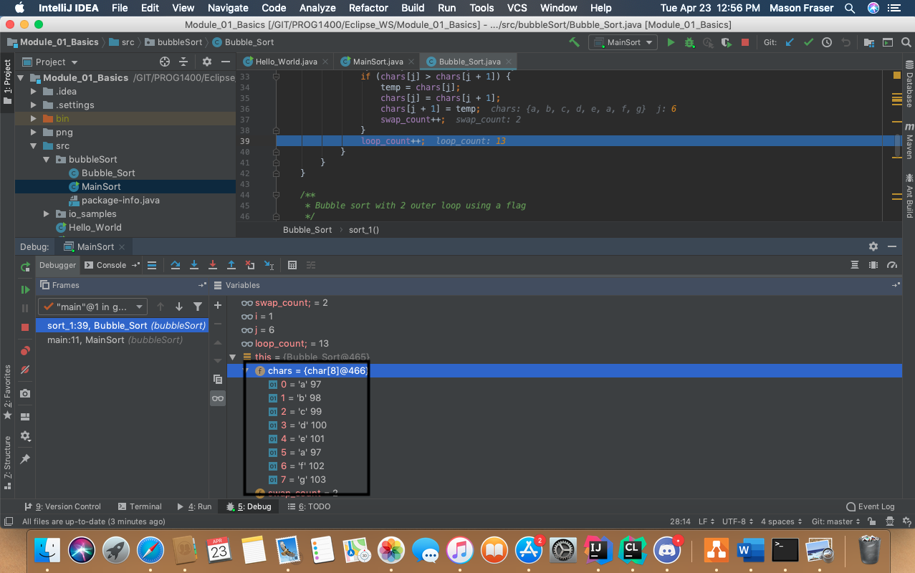
  - [5%] Explain, in text paragraph form, the algorithm difference between sort-1, and sort-2 (the difference between how sort-1and sort-2 are coded, and their use of flags).

  - [5%] Explain, in text paragraph form, the performance difference between sort-1, and sort-2. Would one be faster than the other…all the time?
    - Sort “abcdefg” with each sort…what’s the difference?
    - Sort “abcdefga” with each sort…with the added “a” at the end, what’s the difference?

- Find and run the KaPing mainline at
“PROG1400\Eclipse-WS\Module-02-oo-KaPing\src\sampleKaPing”

KaPing Main line snippet
public static void main(String[] args) {

Random rnd = new Random();

for (int count = 0; count < 10; count++) {

Ball ball = new Ball(rnd.nextInt(30));
Paddle paddle = new Paddle(rnd.nextInt(30), rnd.nextInt(5) + 5);

System.out.println("=========================");

ball.printit();
paddle.printit();

if (paddle.doesItCollide(ball)) {
System.out.println("Ka-Ping"); // Collided
}

}
}

BaseDisplayClass snippet of declared fields
public class BaseDisplayClass {

private int startPos;
private int length;
private char ch = 'X';
…

  - [5%] Looking at BaseDisplayClass, what does “private” mean?

BaseDisplayClass snippet of doesItCollide() method
/**
* Return true if display objects overlap.
*
* @param otherDisplayObject - display object to check against this.
* @return
*/
public boolean doesItCollide(BaseDisplayClass otherDisplayObject) {

if (this == otherDisplayObject) {
System.out.println("Same as me!!!"); // same object, don't compare
}

return ((this.startPos < (otherDisplayObject.startPos + otherDisplayObject.length + 20))
&& (this.startPos + this.length > otherDisplayObject.startPos));

}

  - [5%] Looking at BaseDisplayClass doesItCollide() method, why can this method access the “private” field of both objects, given one object is a “Ball”, and the other is a “Paddle”?

  - [10%] Given (a) and (b) answers, what can you conclude about how you would go about Object Oriented Design?

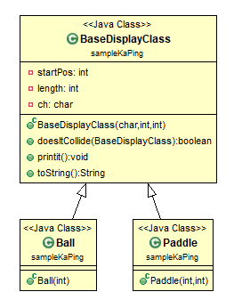
  - [10%] Comment on the relative size of the 3 java files in the class diagram above, why is the BaseDisplayClass larger? Is this good?

- Find and run the mainline at
“PROG1400\Eclipse-WS\Module-15-Callbacks\src\readPNG”…note that the PNG is read using two separate but similar methods.
Also run the mainline at…
“PROG1400\Eclipse-WS\Module-15-Callbacks\src\callbackSample3”

  - [30%] The current callback implementations (MakeCSVCallback and MakeTXTCallback) write a point for every raster pixel. Make your own callback (MakeFINALCallback) that puts a point only if the pixel is not white. The data below shows that white points are 255s, while red and blue have different values. Your callback detects these values, and writes a CSV file (comma separated) with only dots that are red and blue. Note that such an output file can be used as input to your grouped items assignment (…and you can read the secret message).

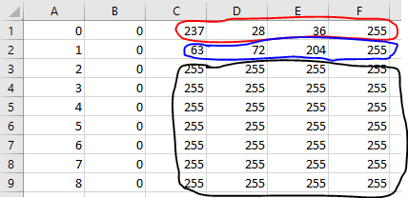

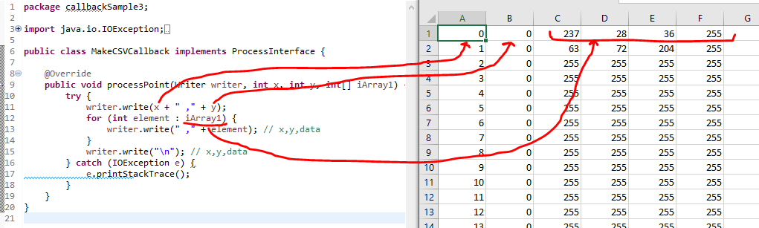

  - [10%] Compare the differences between the original ReadPNGData java that used two similar methods with the use of a callback. Consider “Information Hiding”.
  - [10%] Update the class diagram below to include your new callback.
